SIMATS ENGINEERING

Name : Atsayaa .R
Reg no : (192412024)

ITA0606-
Machine learning

Experiment 2
For a given set of training data examples stored in a .CSV file, implement and demonstrate the Candidate-Elimination algorithm in python to output a description of the set of all hypotheses consistent with the training examples
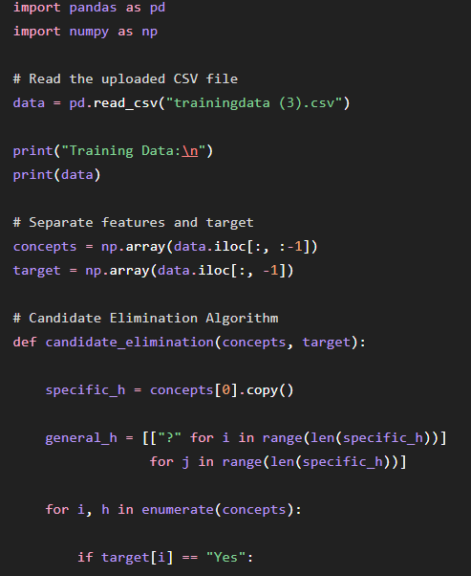
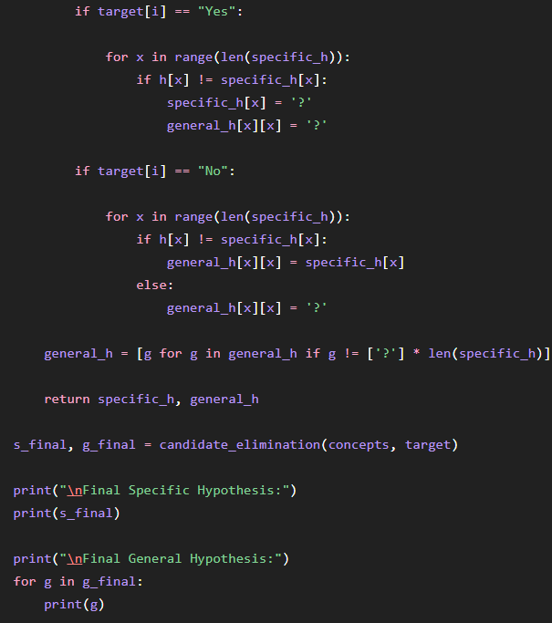

OUTPUT :
